Natural convection coefficient was calculated using a resistor surface temperature of 450K and an ambient air temperature of 298 K.

Geometry:

Length: 49 E-3 m

Diameter:14.8 E-3 m

Surface area:1.33 E-3 m^2

**The following relations were used.**



fundamentals of heat and mass transfer,7th edition, Bergman, Lavine, Incorpera, Dewitt, pg.611

**where**

**At 450 K…**

see citation

see citation

fundamentals of heat and mass transfer,7th edition, Bergman, Lavine, Incorpera, Dewitt, pg.995

https://www.engineeringtoolbox.com/air-density-specific-weight-d_600.html

Pr=0.7 https://www.engineeringtoolbox.com/air-prandtl-number-viscosity-heat-capacity-thermal-conductivity-d_2009.html

**Ra =828805 (unitless) (calculated with above equation)**

 fundamentals of heat and mass transfer,7th edition, Bergman, Lavine, Incorpera, Dewitt, pg.610

<https://www.engineeringtoolbox.com/air-properties-viscosity-conductivity-heat-capacity-d_1509.html?v>

Using fourier’s Law

Area in fourier’s law equals the footprint of the resistor on the PCB.

Width = 14.8 E-3 m

Length = 49.8 E-3 m

Area = 7.37 E-4 m^2

Applied Voltage =12 volts

Working from the different pictures we took…

Measured area on circuit board dimensions

Length of rectangle = 50.35 mm

Width = 31.66 mm

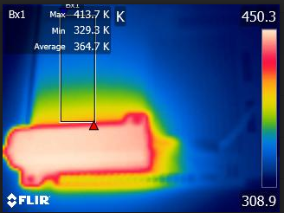

Applied heat:

I only used part of the data in order to get a good fit line to extract dT/dx.

Each temperature line taken from the rectangle is approximately 6 mm apart.

Experimental K values are at the bottom of each table.

|  |  |  |  |  |  |  |  |
| --- | --- | --- | --- | --- | --- | --- | --- |
|  | Distance (m) | T1 | T9 | T17 | T24 | T31 | T38 |
|  | 4.07E-02 | 339.238 | 345.537 | 346.427 | 345.963 | 344.513 | 342.323 |
|  | 3.96E-02 | 340.379 | 346.565 | 347.057 | 346.831 | 345.497 | 343.271 |
|  | 3.86E-02 | 341.521 | 347.351 | 348.027 | 347.978 | 346.427 | 344.263 |
|  | 3.75E-02 | 342.312 | 348.154 | 348.826 | 348.777 | 347.371 | 345.269 |
|  | 3.64E-02 | 343.823 | 348.913 | 349.717 | 349.901 | 348.349 | 346.091 |
|  | 3.54E-02 | 345.001 | 350.036 | 350.854 | 350.777 | 349.369 | 347.293 |
|  | 3.43E-02 | 346.24 | 351.123 | 351.754 | 351.735 | 350.267 | 348.319 |
|  | 3.32E-02 | 347.557 | 352.108 | 352.821 | 352.84 | 351.582 | 349.456 |
|  | 3.21E-02 | 348.553 | 353.039 | 354.06 | 354.05 | 352.735 | 350.816 |
|  | 3.11E-02 | 349.969 | 354.812 | 355.412 | 355.468 | 354.032 | 351.917 |
|  | 3.00E-02 | 351.535 | 355.757 | 356.725 | 356.725 | 355.449 | 353.266 |
|  | 2.89E-02 | 352.745 | 357.087 | 357.789 | 358.093 | 356.781 | 354.248 |
|  | 2.79E-02 | 354.145 | 358.13 | 358.92 | 359.442 | 357.918 | 355.627 |
|  | 2.68E-02 | 355.608 | 359.259 | 360.154 | 360.454 | 359.25 | 357.253 |
|  | 2.57E-02 | 357.013 | 360.626 | 361.496 | 361.713 | 360.59 | 358.415 |
|  | 2.46E-02 | 358.333 | 361.992 | 362.784 | 363.053 | 362.082 | 360.126 |
|  | 2.36E-02 | 359.497 | 363.169 | 364.312 | 364.854 | 363.697 | 361.875 |
|  | 2.25E-02 | 361.161 | 364.614 | 365.933 | 366.224 | 365.323 | 363.303 |
|  | 2.14E-02 | 362.909 | 366.233 | 367.19 | 367.951 | 366.804 | 365.164 |
|  | 2.04E-02 | 364.49 | 367.75 | 368.761 | 369.464 | 368.813 | 366.866 |
|  | 1.93E-02 | 366.092 | 369.447 | 370.509 | 371.462 | 370.569 | 368.726 |
|  | 1.82E-02 | 367.846 | 370.982 | 372.343 | 373.194 | 372.454 | 370.664 |
|  | 1.71E-02 | 369.559 | 372.735 | 373.864 | 374.784 | 374.202 | 372.735 |
|  | 1.61E-02 | 371.471 | 374.481 | 376.027 | 376.83 | 376.454 | 375.146 |
|  | 1.50E-02 | 373.389 | 376.446 | 377.894 | 378.623 | 378.441 | 377.146 |
|  | 1.39E-02 | 375.272 | 378.474 | 379.727 | 380.826 | 380.572 | 379.711 |
|  | 1.29E-02 | 377.005 | 380.212 | 381.805 | 383.014 | 382.933 | 382.146 |
|  | 1.18E-02 | 379.151 | 382.285 | 383.878 | 385.187 | 385.451 | 384.875 |
|  | 1.07E-02 | 381.169 | 384.626 | 386.425 | 387.774 | 387.924 | 387.798 |
|  | 9.64E-03 | 383.789 | 386.664 | 388.556 | 389.915 | 390.603 | 390.658 |
| dt/dx |  | -1403 | -1302 | -1337 | -1389 | -1447 | -1504 |
| **K W/m*K** |  | **13.12365149** | **14.14169204** | **13.77149068** | **13.25592731** | **12.7245909** | **12.24234245** |

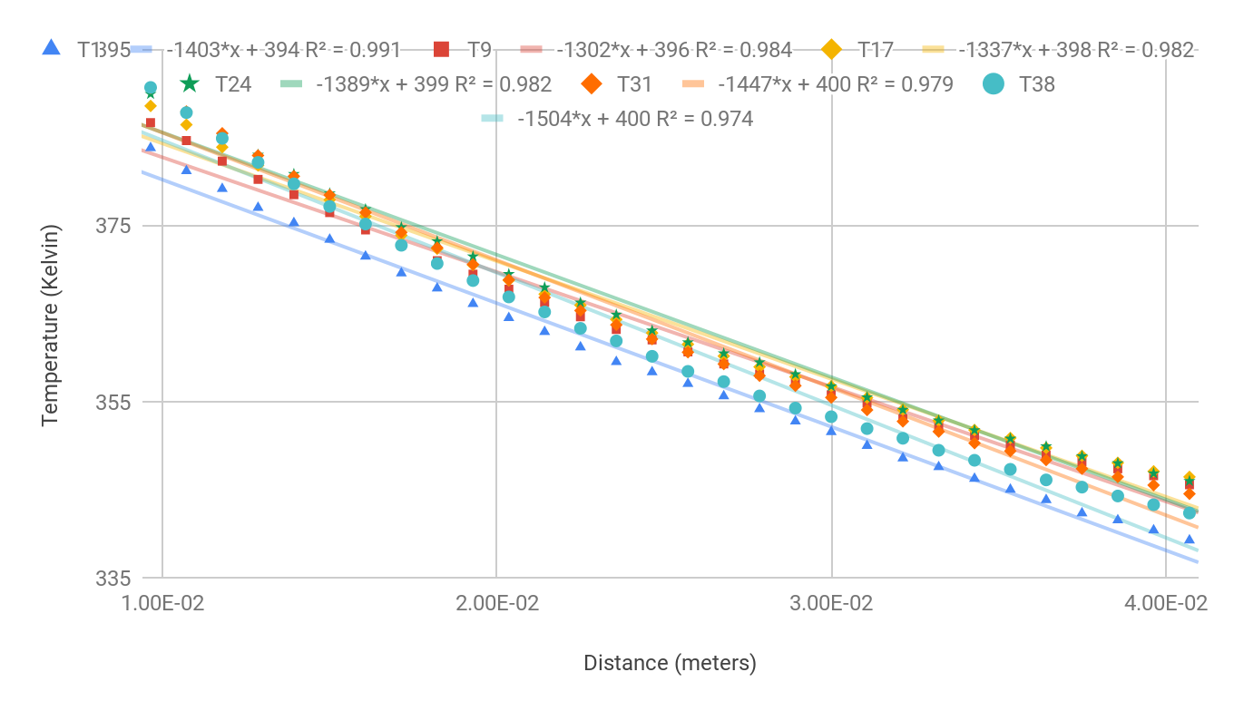

**Line 3**

Temperature of the resistor is less than 1K less than the previous picture. This will change the convective heat coefficient by less than our working sig figs. Using the same loss to natural convection as the previous figure.

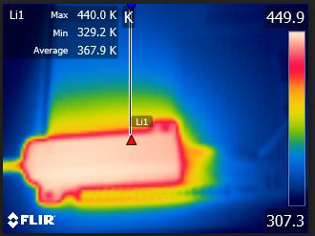

Applied heat:

|  |  |  |
| --- | --- | --- |
|  | Distance (meters) | Temperature (Kelvin) |
|  | 0.00944064 | 391.468 |
|  | 1.05E-02 | 388.871 |
|  | 1.15E-02 | 386.512 |
|  | 0.01258752 | 384.152 |
|  | 1.36E-02 | 381.748 |
|  | 1.47E-02 | 379.464 |
|  | 0.0157344 | 377.313 |
|  | 1.68E-02 | 375.356 |
|  | 1.78E-02 | 373.279 |
|  | 0.01888128 | 371.471 |
|  | 1.99E-02 | 369.672 |
|  | 2.10E-02 | 367.82 |
|  | 0.02202816 | 366.101 |
|  | 2.31E-02 | 364.561 |
|  | 2.41E-02 | 362.981 |
|  | 0.02517504 | 361.306 |
|  | 2.62E-02 | 360.017 |
|  | 2.73E-02 | 358.618 |
|  | 0.02832192 | 357.327 |
|  | 2.94E-02 | 356.102 |
|  | 3.04E-02 | 354.624 |
|  | 0.0314688 | 353.399 |
|  | 3.25E-02 | 352.06 |
|  | 3.36E-02 | 351.056 |
|  | 0.03461568 | 350.055 |
|  | 3.57E-02 | 348.748 |
|  | 3.67E-02 | 347.978 |
|  | 0.03776256 | 346.831 |
|  | 3.88E-02 | 345.963 |
|  | 3.99E-02 | 345.1 |
|  | 0.04090944 | 344.263 |
|  | 4.20E-02 | 343.16 |
|  | 4.30E-02 | 342.505 |
|  | 0.04405632 | 341.725 |
|  | 4.51E-02 | 340.818 |
|  | 4.62E-02 | 340.44 |
| dt/dx |  | -1360 |
| **k W/m*k** |  | **13.53859047** |

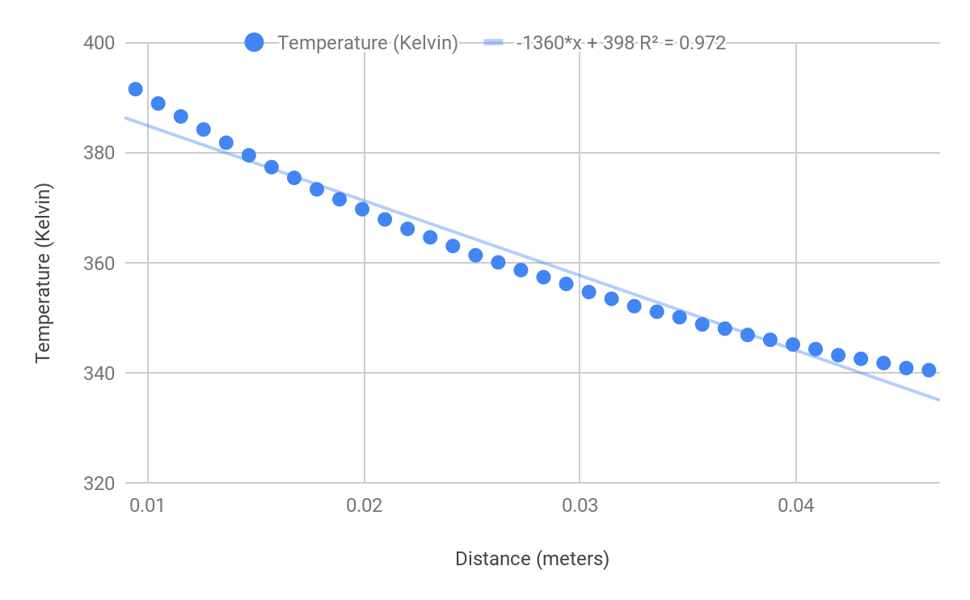

**Line 2**

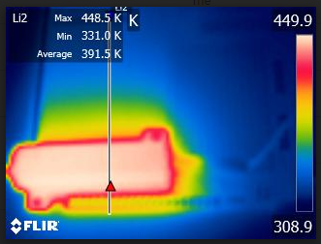

|  |  |  |
| --- | --- | --- |
|  | Distance (meters) | Temperature (Kelvin) |
|  | 0.06957108067 | 340.102 |
|  | 6.86E-02 | 340.859 |
|  | 6.76E-02 | 341.471 |
|  | 0.06667228567 | 342.363 |
|  | 6.57E-02 | 343.009 |
|  | 6.47E-02 | 343.993 |
|  | 0.06377349067 | 344.652 |
|  | 6.28E-02 | 345.676 |
|  | 6.18E-02 | 346.683 |
|  | 0.06087469567 | 347.322 |
|  | 5.99E-02 | 348.466 |
|  | 5.89E-02 | 349.408 |
|  | 0.05797590067 | 350.296 |
|  | 5.70E-02 | 351.563 |
|  | 5.60E-02 | 352.811 |
|  | 0.05507710567 | 353.871 |
|  | 5.41E-02 | 355.412 |
|  | 5.31E-02 | 356.679 |
|  | 0.05217831067 | 357.614 |
|  | 5.12E-02 | 358.884 |
|  | 5.02E-02 | 360.372 |
|  | 0.04927951567 | 361.568 |
|  | 4.83E-02 | 363.384 |
|  | 4.73E-02 | 364.907 |
|  | 0.04638072067 | 366.585 |
|  | 4.54E-02 | 368.256 |
|  | 4.44E-02 | 370.242 |
|  | 0.04348192567 | 371.89 |
|  | 4.25E-02 | 373.796 |
|  | 4.15E-02 | 376.044 |
|  | 0.04058313067 | 378.06 |
|  | 3.96E-02 | 380.105 |
|  | 3.87E-02 | 382.512 |
|  | 0.03768433567 | 384.69 |
|  | 3.67E-02 | 387.14 |
|  | 3.58E-02 | 389.664 |
|  | 0.03478554067 | 392.051 |
|  | 3.38E-02 | 394.979 |
|  | 3.29E-02 | 398.006 |
|  | 0.03188674567 | 400.836 |
|  | 3.09E-02 | 404.221 |
| dt/dx |  | -1.59E+03 |
| **K W/mK** |  | **1.16E+01** |

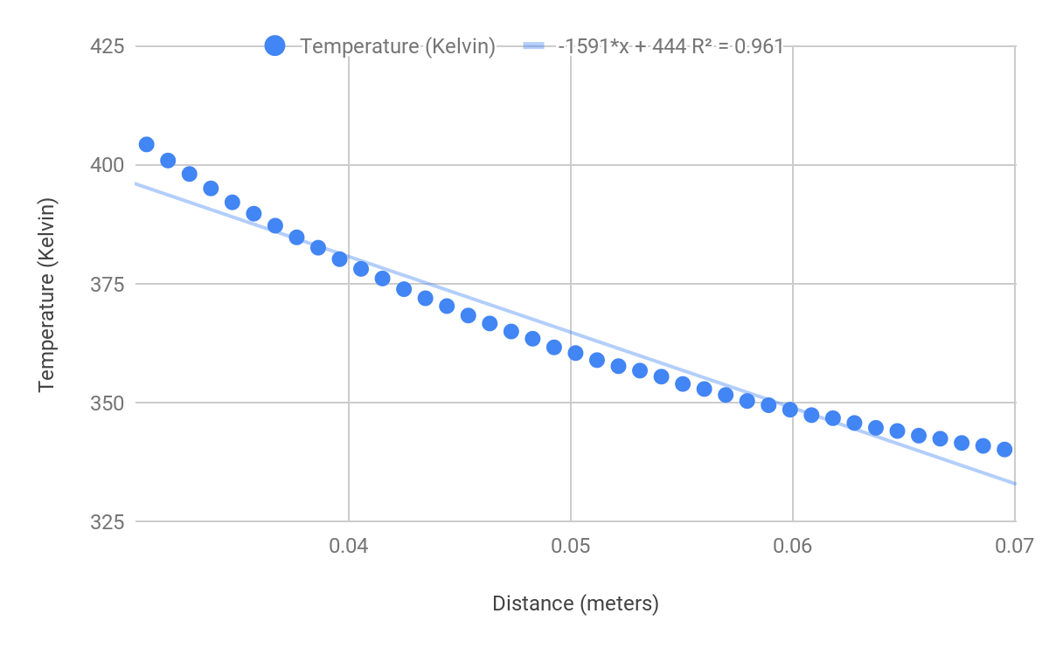

**Line 4**

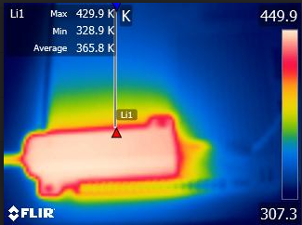

|  |  |  |
| --- | --- | --- |
|  | Distance (meters) | Temperature (Kelvin) |
|  | 0.003213826667 | 405.08 |
|  | 4.29E-03 | 401.96 |
|  | 5.36E-03 | 398.767 |
|  | 0.006427651667 | 395.743 |
|  | 7.50E-03 | 393.026 |
|  | 8.57E-03 | 390.361 |
|  | 0.009641476667 | 387.853 |
|  | 1.07E-02 | 385.323 |
|  | 1.18E-02 | 383.03 |
|  | 0.01285530167 | 380.761 |
|  | 1.39E-02 | 378.648 |
|  | 1.50E-02 | 376.755 |
|  | 0.01606912667 | 374.54 |
|  | 1.71E-02 | 372.811 |
|  | 1.82E-02 | 370.827 |
|  | 0.01928295167 | 369.091 |
|  | 2.04E-02 | 367.26 |
|  | 2.14E-02 | 365.757 |
|  | 0.02249677667 | 364 |
|  | 2.36E-02 | 362.46 |
|  | 2.46E-02 | 360.935 |
|  | 0.02571060167 | 359.497 |
|  | 2.68E-02 | 358.379 |
|  | 2.79E-02 | 357.152 |
|  | 0.02892442667 | 355.841 |
|  | 3.00E-02 | 354.709 |
|  | 3.11E-02 | 353.437 |
|  | 0.03213825167 | 351.831 |
|  | 3.32E-02 | 350.701 |
|  | 3.43E-02 | 349.766 |
|  | 0.03535207667 | 348.787 |
|  | 3.64E-02 | 347.851 |
|  | 3.75E-02 | 346.821 |
|  | 0.03856590167 | 345.706 |
|  | 3.96E-02 | 345.2 |
|  | 4.07E-02 | 344.183 |
|  | 0.04177972667 | 343.662 |
|  | 4.29E-02 | 342.575 |
|  | 4.39E-02 | 341.958 |
|  | 0.04499355167 | 341.267 |
|  | 4.61E-02 | 340.358 |
|  | 4.71E-02 | 339.393 |
| dt/dx |  | -1427 |
| **K W/mK** |  | **12.90293135** |

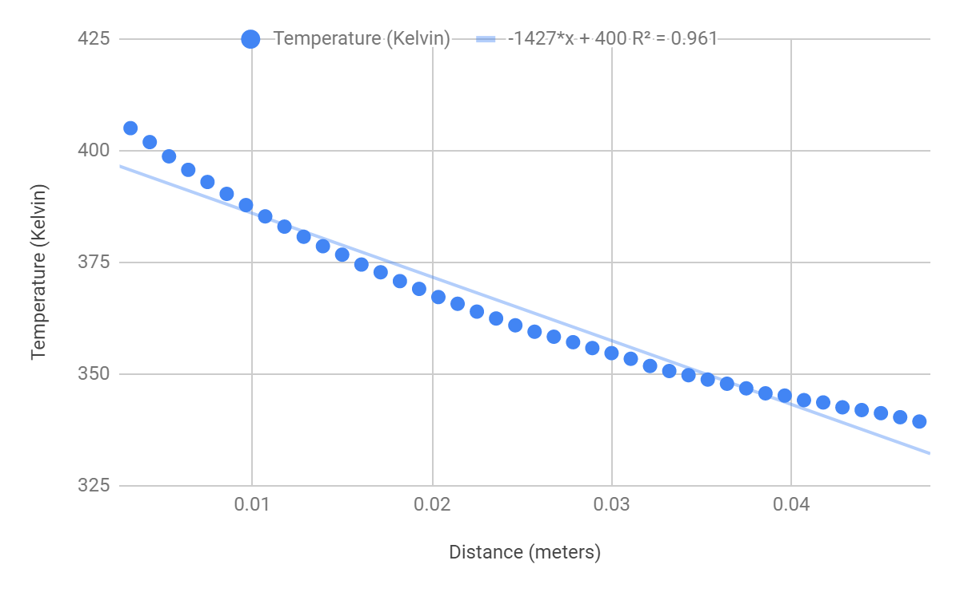

**New Data Set @ 6 Volts**

Natural convection coefficient was calculated using a resistor surface temperature of 341K and an ambient air temperature of 298 K.

Ra=6.87198 E6

Nu=27.648

Area measurement

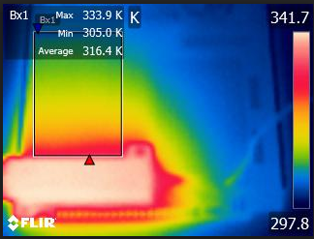

|  |  |  |  |  |  |  |
| --- | --- | --- | --- | --- | --- | --- |
|  | Distance (meters) | t 8 | t 15 | t 22 | t 29 | t 34 |
|  | 0.03535207667 | 311.653 | 311.552 | 311.728 | 310.998 | 310.669 |
|  | 3.43E-02 | 312.104 | 312.054 | 311.941 | 311.552 | 311.074 |
|  | 3.32E-02 | 312.191 | 312.229 | 312.504 | 311.703 | 311.389 |
|  | 0.03213825167 | 312.566 | 312.666 | 312.753 | 312.191 | 312.029 |
|  | 3.11E-02 | 313.213 | 313.113 | 313.25 | 312.628 | 312.329 |
|  | 3.00E-02 | 313.485 | 313.349 | 313.473 | 313.25 | 312.653 |
|  | 0.02892442667 | 313.868 | 313.794 | 313.831 | 313.547 | 313.237 |
|  | 2.79E-02 | 314.041 | 314.275 | 314.287 | 313.992 | 313.461 |
|  | 2.68E-02 | 314.607 | 314.68 | 314.594 | 314.386 | 314.004 |
|  | 0.02571060167 | 314.766 | 314.987 | 315.207 | 314.668 | 314.484 |
|  | 2.46E-02 | 315.402 | 315.426 | 315.621 | 315.121 | 314.852 |
|  | 2.36E-02 | 315.694 | 315.986 | 315.937 | 315.597 | 315.28 |
|  | 0.02249677667 | 316.204 | 316.434 | 316.483 | 315.986 | 315.706 |
|  | 2.14E-02 | 316.676 | 316.857 | 317.038 | 316.507 | 316.156 |
|  | 2.04E-02 | 317.098 | 317.122 | 317.471 | 316.869 | 316.628 |
|  | 0.01928295167 | 317.375 | 317.711 | 317.687 | 317.759 | 317.122 |
|  | 1.82E-02 | 317.782 | 318.129 | 318.261 | 318.141 | 317.711 |
|  | 1.71E-02 | 318.392 | 318.701 | 318.892 | 318.701 | 318.237 |
|  | 0.01606912667 | 318.963 | 318.987 | 319.65 | 319.165 | 318.832 |
|  | 1.50E-02 | 319.591 | 319.838 | 319.803 | 319.756 | 319.401 |
|  | 1.39E-02 | 320.062 | 320.333 | 320.497 | 320.392 | 320.215 |
|  | 0.01285530167 | 320.603 | 320.837 | 321.165 | 321.375 | 320.954 |
|  | 1.18E-02 | 321.305 | 321.712 | 322.014 | 322.049 | 321.584 |
|  | 1.07E-02 | 321.887 | 322.072 | 322.582 | 322.698 | 322.339 |
|  | 0.009641476667 | 322.744 | 322.871 | 323.262 | 323.251 | 323.17 |
| dt/dx | -416 | -416 | -429 | -440 | -466 | -468 |
| **K W/mK** | **11.08965661** | **11.08965661** | **10.75360641** | **10.48476625** | **9.899779293** | **9.857472544** |

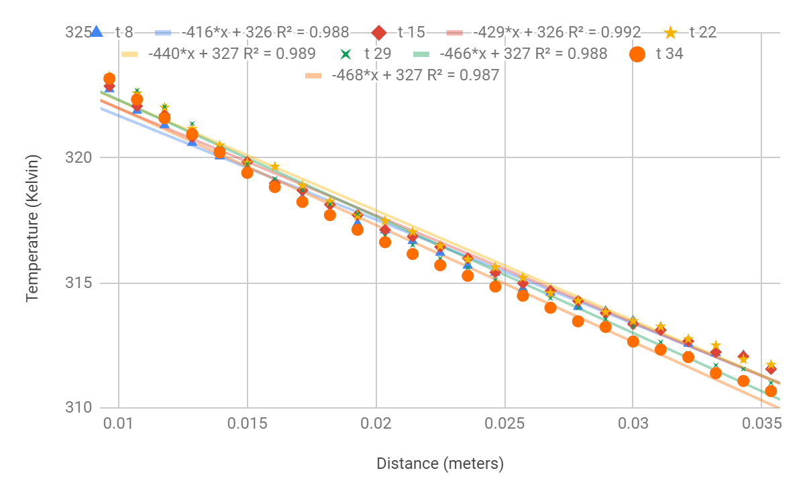

6 volt Trial 1

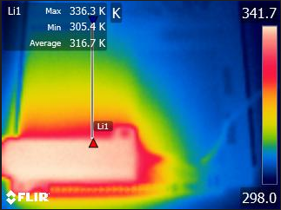

|  |  |  |
| --- | --- | --- |
|  | distance (Meters) | Temperature (Kelvin) |
|  | 2.06E-02 | 317.014 |
|  | 0.02157855 | 316.483 |
|  | 2.26E-02 | 316.144 |
|  | 2.36E-02 | 315.658 |
|  | 0.0246612 | 315.28 |
|  | 2.57E-02 | 314.876 |
|  | 2.67E-02 | 314.484 |
|  | 0.02774385 | 314.14 |
|  | 2.88E-02 | 313.683 |
|  | 2.98E-02 | 313.25 |
|  | 0.0308265 | 312.765 |
|  | 3.19E-02 | 312.341 |
|  | 3.29E-02 | 311.891 |
|  | 0.03390915 | 311.703 |
|  | 3.49E-02 | 311.338 |
|  | 3.60E-02 | 310.948 |
|  | 0.0369918 | 310.783 |
|  | 3.80E-02 | 310.556 |
|  | 3.90E-02 | 310.137 |
|  | 0.04007445 | 309.971 |
|  | 4.11E-02 | 309.627 |
|  | 4.21E-02 | 309.334 |
| dT/dx |  | -358 |
| **K W/mK** |  | **12.88630489** |

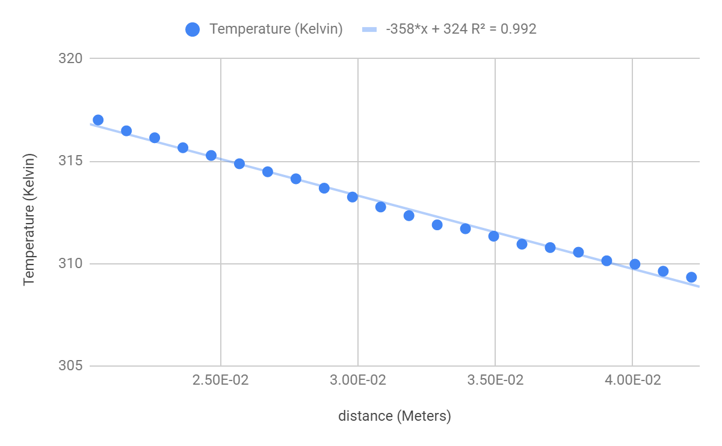

6 Volt trial 2

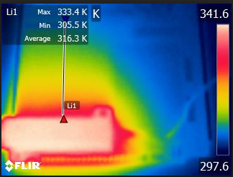

|  |  |  |
| --- | --- | --- |
|  | Distance (meters) | Temperature (Kelvin) |
|  | 0.01888128 | 317.627 |
|  | 1.99E-02 | 317.23 |
|  | 2.10E-02 | 316.905 |
|  | 0.02202816 | 316.216 |
|  | 2.31E-02 | 315.84 |
|  | 2.41E-02 | 315.341 |
|  | 0.02517504 | 315.048 |
|  | 2.62E-02 | 314.472 |
|  | 2.73E-02 | 314.189 |
|  | 0.02832192 | 313.856 |
|  | 2.94E-02 | 313.448 |
|  | 3.04E-02 | 312.89 |
|  | 0.0314688 | 312.716 |
|  | 3.25E-02 | 312.304 |
|  | 3.36E-02 | 311.791 |
|  | 0.03461568 | 311.628 |
|  | 3.57E-02 | 311.351 |
|  | 3.67E-02 | 310.973 |
|  | 0.03776256 | 310.669 |
|  | 3.88E-02 | 310.15 |
| dT/dx |  | -370 |
| **K W/mK** |  | **12.46837068** |

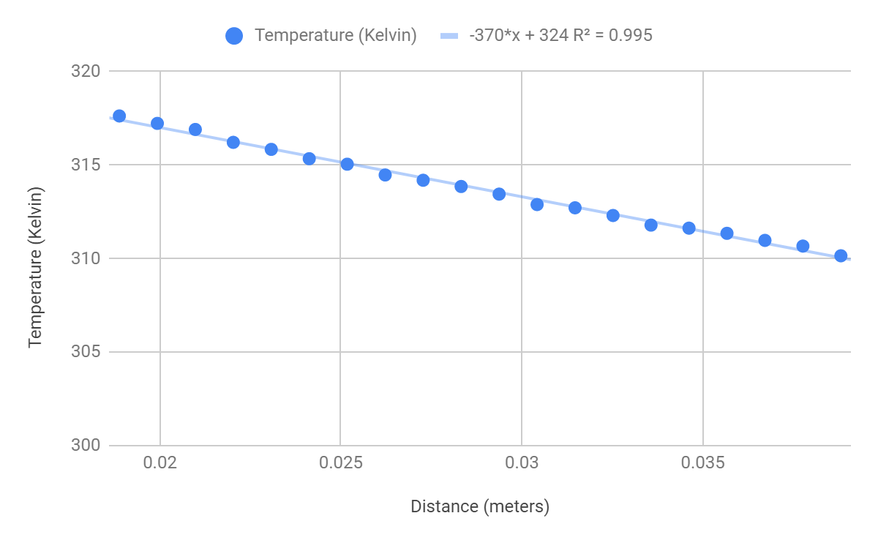

Thermal Conductivity Values w/ voltages separate

|  |  |  |
| --- | --- | --- |
|  | Experimental Thermal Conductivity | |
|  | 12 Volt | 6 Volt |
|  | 13.12365149 | 11.08965661 |
|  | 14.14169204 | 11.08965661 |
|  | 13.77149068 | 10.75360641 |
|  | 13.25592731 | 10.48476625 |
|  | 12.7245909 | 9.899779293 |
|  | 12.24234245 | 9.857472544 |
|  | 13.53859047 | 12.88630489 |
|  | 1.16E+01 | 12.4683706 |
|  | 12.90293135 |  |
| average | 13.03346852 | 11.06620165 |
| standard deviation | 0.7809259678 | 1.104361736 |

Thermal Conductivity Values w/ voltages together

|  |  |
| --- | --- |
|  | Experimental Thermal Conductivity |
|  | 13.12365149 |
|  | 14.14169204 |
|  | 13.77149068 |
|  | 13.25592731 |
|  | 12.7245909 |
|  | 12.24234245 |
|  | 13.53859047 |
|  | 1.16E+01 |
|  | 12.90293135 |
|  | 13.03346852 |
|  | 11.08965661 |
|  | 11.08965661 |
|  | 10.75360641 |
|  | 10.48476625 |
|  | 9.899779293 |
|  | 9.857472544 |
|  | 12.88630489 |
|  | 12.4683706 |
| average | 12.15912769 |
| standard deviation | 1.342006495 |